full-stack project

* Real-time bidding logic
* User roles (admin, team owners, auctioneer)
* Timer control (for bids)
* Player database management
* WebSocket-based live updates (if going real-time)

Core Features You Can Include:

|  |  |
| --- | --- |
| Feature | Description |
| User Roles | Admin (organizes), Team Owners (bid), Viewer (spectator mode) |
| Player Pool | Upload player list with base price, roles (batsman, bowler, etc.) |
| Auction Mechanism | Timer per player, live bidding, highest bidder wins |
| Wallet/Budget System | Team owners have a fixed budget; can't bid beyond it |
| Team Composition | Team owners can’t exceed a player limit (e.g., 15 players, 4 overseas) |
| Live Auction Updates | Use **WebSockets** for real-time bid updates across all clients |
| Admin Panel | Add players, control auction start/stop, timer reset, etc. |
| Past Bid History | Show player price, who won, etc. |
|  |  |

**Tech Stack**

* **Frontend**: React (with Redux or Context API for state management)
* **Backend**: Spring Boot (REST APIs + WebSocket support)
* **Database**: MySQL or PostgreSQL (store players, teams, bids)
* **WebSocket (for real-time)**: spring-boot-starter-websocket + Socket.IO or STOMP with SockJS on frontend

**Frontend Features (React)**

* Login/Register page
* Team dashboard (see your team, remaining balance)
* Live auction screen with:
  + Current player
  + Timer countdown
  + Bidding buttons
  + Real-time updates of highest bid

**Backend Responsibilities (Spring Boot)**

* REST APIs:
  + Login / Register / Get players / Place bid / Get team details
* WebSocket:
  + Broadcast current player and live bids
* Auction logic (timers, bid validations, winner handling)
* Admin APIs (start auction, pause, next player, etc.)

**Strategy**

You should **build a working MVP in 2 weeks** first:

* Static player list
* Bid button with bid increase logic
* Team budget check
* Basic React UI + REST APIs

Then add fancy things like:

* WebSocket live updates
* Admin controls
* Fancy charts/team pages

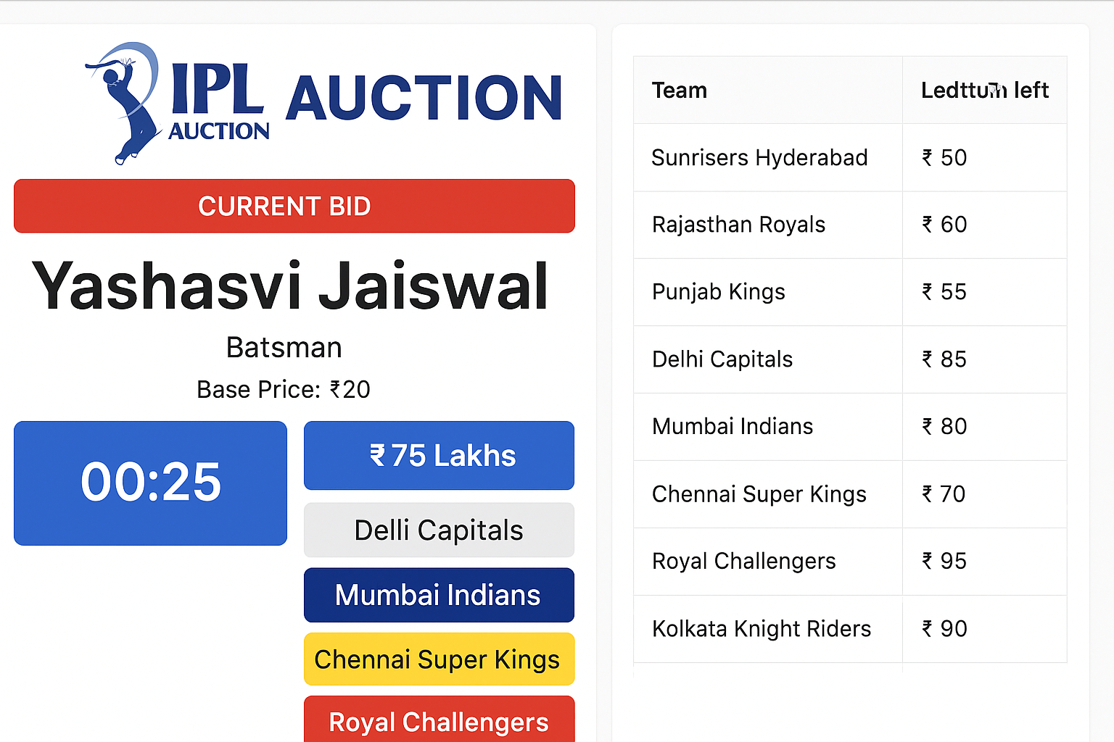

Flowchart

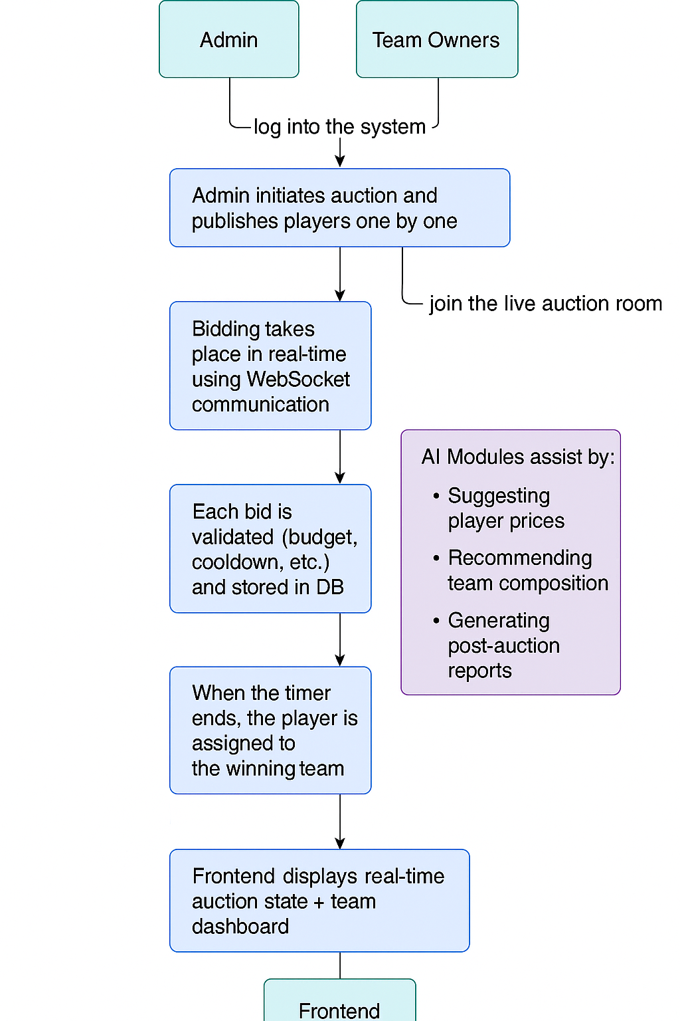

System Architecture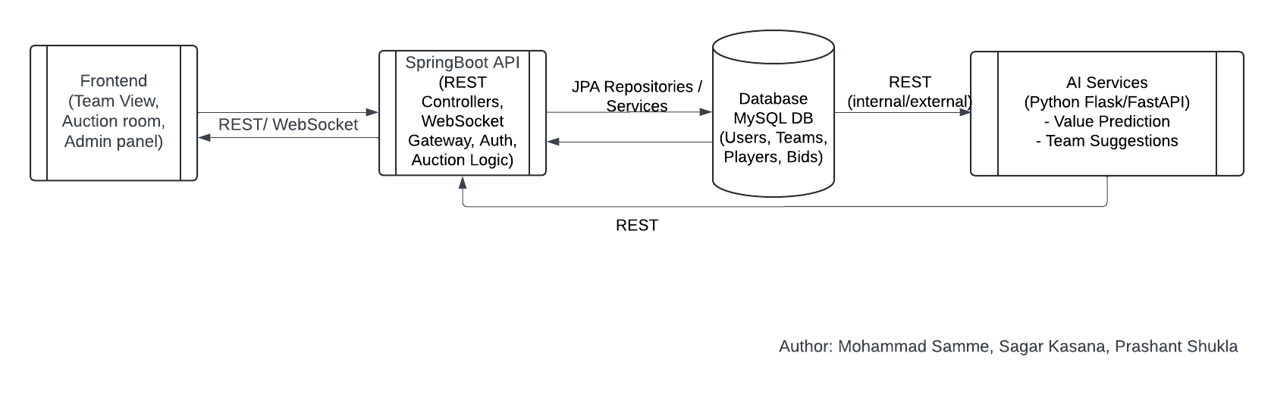

Tu basically ek **"Smart IPL Auction Assistant"** banana chahta hai jo:

* **Player ke stats instantly de**
* **AI/ML ke through**:
  + Player ki **value** estimate kare
  + Squad **requirement match** kare
  + Bole: *“Yeh player ₹X tak ka worth hai, le le ya chhod de”*

AI checks:

* Squad needs (e.g., ek bowler chahiye kya?)
* Player's form, consistency
* Fit in your team (e.g., already 3 openers hain?)
* Past auction prices (similar profiles)

ML Prediction:

* “Recommend up to ₹X crore”

**OUTPUT:**

Player: Shivam Dube

Role: Batting All-rounder

Fit in Team: ✅ Middle-order finisher needed

Recommend Bid: ₹6.5 crore

Max Stretch: ₹8 crore

Risk: Medium (vs spin struggle)

**How to Build This Service?**

1. 📂 Dataset Required:

* Historical auction data (player → sold price)
* Player stats (IPL + domestic + int’l)
* Player roles
* Squad structures
* Injury / availability data (optional)

**2. 🧠 ML Model Ideas:**

* **Regression** model: Predict price (₹)
* **Classification**: Good Fit / Maybe / No Fit
* Features:
  + Recent form
  + Bat/bowl type
  + Consistency
  + Performance vs top teams
  + Team needs (based on current squad)

**3. 🛠️ Architecture Flow**

Player Name → [API Call] → Fetch Player Stats

↓

AI Layer (ML Model)

↓

➤ Recommend Price

➤ Fit Score (0–1)

➤ Role Match

↓

Final Recommendation Output

**Step 1: Data Collection**

Tera AI auction assistant tabhi kaam karega jab uske paas solid **data** hoga. Sabse pehle humein 2 types ke data chahiye:

**A. Player Performance Data**

**For each player**, humein yeh chahiye:

| **Field** | **Example** |
| --- | --- |
| Name | Shivam Dube |
| Role | Batting All-rounder |
| Batting Style | Left-handed |
| Bowling Style | Right-arm medium |
| Matches Played | 40 |
| Bat Avg | 28.5 |
| SR | 145.2 |
| Bowl Econ | 8.2 |
| Wickets | 18 |
| IPL Team | CSK |
| Year Active | 2019–2024 |
| Country | India |

**B. Auction History (If available)**

| **Name** | **Year** | **Sold Price** | **Base Price** | **Team** |
| --- | --- | --- | --- | --- |
| Shivam Dube | 2022 | ₹4 crore | ₹50 lakh | CSK |
| Pat Cummins | 2020 | ₹15.5 crore | ₹2 crore | KKR |

**From base data → scrape individual player pages → fetch more info like:**

* Full name
* Born (DOB)
* Current age
* Major teams
* Playing role
* Batting style
* Bowling style
* Profile summary (optional)

